~~Thoughts/Suggestions:~~

1. ~~Use SEM theory to construct latent predictor variables based on multiple, correlated covariates.~~

~~Example: Instead of only using raven abundance as an explanatory variable, each of the predator indices can be included, and we used the latent trend in predator abundance as our explanatory variables.~~

~~n.indices = 4~~

~~for(i in 1:n.indices){~~

~~sig.pred[i] ~ dgamma(1,1)~~ **~~# Error term for each index (since they are standardized, should be close to 1)~~**

~~mu_p[i] ~ dnorm(0, 1)~~ **~~# Intecept term for each index (since they are standardized, should be close to 0)~~**

~~}~~

**~~# Zeta represents how correlated each index is to our reference index, we must fix zeta to 1.0 for one of the indices (reference index). It shouldn’t matter the variable selected, however, the stronger the correlation is, the more effective this approach is at estimating the latent process.~~**

~~zeta[1] <- 1~~

~~for(i in 2:n.indices){~~

~~zeta[i] ~ dnorm(0, 1)~~ **~~# Since each index is z-standardized, this prior is justified.~~**

~~}~~

~~for(t in 1:n.year){~~

~~pred.prime[t] ~ dnorm(0, 1)~~ **~~# Latent Predator Index: There is no data directly informing this.~~**

~~ravens[t] ~ dnorm(mu.pred[1,t], sd = sig.pred[1])~~ **~~# Raven index~~**

~~rthawk[t] ~ dnorm(mu.pred[2,t], sd = sig.pred[2])~~ **~~# Red-tailed hawk index~~**

~~nharr[t] ~ dnorm(mu.pred[3,t], sd = sig.pred[3])~~ **~~# Harrier index~~**

~~pfal[t] ~ dnorm(mu.pred[4,t], sd = sig.pred[4])~~ **~~# Prairie falcon index~~**

~~mu.pred[1,t] <- mu_p[1] + zeta[1] * pred.prime[t]~~

~~mu.pred[2,t] <- mu_p[2] + zeta[2] * pred.prime[t]~~

~~mu.pred[3,t] <- mu_p[3] + zeta[3] * pred.prime[t]~~

~~mu.pred[4,t] <- mu_p[4] + zeta[4] * pred.prime[t]~~

~~}~~

~~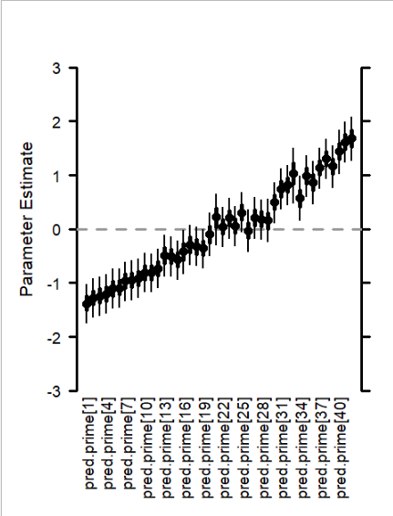~~

~~As you can see, pred.prime represents the annual variation in predator abundance that is shared across each of the 4 indices, and may be more justifiable than just selecting one index due to concerns regarding correlated covariates. This will most likely not improve the precision of the predictions, but it may be more justified and is in the spirit of the rest of the model. And just to reiterate, in this case, pred.prime is fit as an explanatory variable in other parts of the model (e.g., harvest model). The four predator indices are only used to inform pred.prime.~~

1. ~~Only use covariates that we do not have to make a ‘future’ prediction for. It appears to be that the last (e.g., 2017) value for a few explanatory variables were censored/fit as an NA in the prediction model, which would require the model to estimate a value for that final year and fit that value (and its associated uncertainty) to the hunter and harvest models. In short, double check that we aren’t estimating things that we don’t need to estimate due to their availability when we would be making a prediction. I made some changes to the data prep code to ensure that these 2017 values were being used to inform the predictions.~~
2. ~~Likewise, I would consider dropped the winter severity variable on the hunter model since it appears to be asking whether the winter severity~~ *~~after~~* ~~the hunting season influenced hunter effort, which has some inferential issues as well as is never something we would be able to fit to a predict.~~
3. ~~Re-consider including some type of spring-summer PDSI value in the harvest model. This information would be available prior to making a prediction for the harvest season, so it should be included even if it’s only weakly explanatory.~~

**~~# My proposed model(s)~~**

~~mu.hunt[s,t,r] <- alpha.hunt[s,r] + #intercept~~

~~# some type of economic index (similar to the predator index, a SEM approach could be used if there are correlated variables~~

~~beta.jobs[s] * une[t] +~~

~~inprod(beta.spl.hunt[s,r,1:K], Z.hunt[t,1:K,s,r]) #spline smoothing~~

~~mu.harv[s,t,r] <-~~

~~alpha.harv[s,r] + # intercepts~~

~~beta.hunter.harv[s] * ((n.hunt[s,t,r] - mean(n.hunt[s,1:n.year,r]))/sd(n.hunt[s,1:n.year,r])) + # Current season hunter numbers~~

~~beta.wintsev.harv[s] * awssi[r,t] + # Previous winter severity (Affecting Survival)~~

~~beta.pdsi.harv[s] * pdsi[t,r] + # Current spring/summer drought (Affecting Survival/Reproduction)~~

~~beta.raven.harv[s] * pred.prime[t] + # Latent predator index (Affecting Reproduction)~~

~~inprod(beta.spl.harv[s,r,1:K], Z.harv[t,1:K,s,r]) # Spline smoothing~~

1. ~~Potential consider dropping the spline from the harvest model, but retain it in the hunter model. I haven’t delved into whether this would increase/decrease bias or precision, but it’s worth considering. Basically, since our metric of interest is birds per hunter, it is influenced by two splines (one for the hunters, one for the residual change in harvest) plus the association between hunters and harvest, which may be inflating the uncertainty in the model.~~
2. ~~Drop underperforming species that are of low interest to NDOW (e.g., rabbits, quail). Dropping them may improve the fit of the correlation structure, which in turn increase prediction precision. I have not tested this.~~
3. ~~Make sure that the posterior distribution is at least 15,000 samples after burn-in and thinning.~~

~~e.g., runMCMC(Cmcmc,nburnin = 50000, niter = 125000, thin = 5, thin2 = 5)~~

7-28-2022

~~Ok, I've attached some code for what I think is an improved model to use going forwards that I feel results in predictions with a reasonable amount of error that appear to be accurate as we are going to get in the absence of some major change to the approach.~~

Before I get into what I did, here is what the modified model predicts for birds per hunter in 2017 with 2017 excluded, where the gray dot is the reported value. Not perfect, but good enough for this deployment. Also, I am going to lean on this point a few times, I don't believe we need to be beholden to 95% confidence intervals for our predictions. The uncertainty here is 85% highest posterior densities, I am comfortable with scaling back our alpha level here. So, unless anyone has any strong opinions about this, I am recommending that we be a little more liberal with our acceptance of potential error.

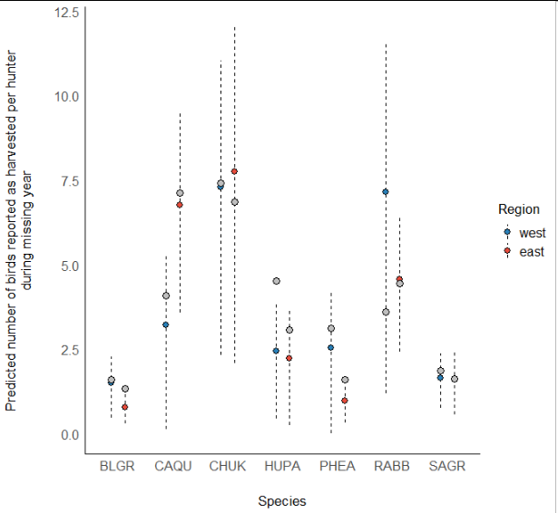

What are the changes made and suggestions for the future?

~~1) The big one is to move away from a poisson model. I don't think the mean == variance in the data, so this was probably the wrong model to use on the outset. I am recommending switching to a normal distribution for both the counts of hunters and harvest. And to improve convergence we can divide both the number of hunters and birds harvested by 1,000 and keep the linear model on the log-scale. See lines 95, 176 in the model and 313 and 317 in the data (there are also changes made for the inits). I think this really improved model fit. I strongly recommend keeping this.~~

~~2) Somewhere along the line your current model lost the link between the numbers of hunters and birds harvested in the linear harvest model. This is pretty important to keep in as these two processes are inherently correlated with each other. I am leaning hard into retaining the approach I suggested last time, which is to model the latent trend in hunter abundance with a simplified spline model, and fit that latent trend as a covariate in both the harvest model and the chukar count model. The simplified spline structure (line 295) will allow for more flexibility into forecasting farther in the future, and linking the chukar (line 230) , harvest (line 167), and hunter data (line 90) together was an initial objective for this analysis and decreases the amount of redundant parameter (i.e., the independent spline trends for the hunter and harvest data were primarily doing the same thing).~~

3) Back to your original question regarding how to generate out-of-model confidence intervals for predictions made by the user, see the example at lines 671-701. In short, instead of using the upper and lower limits, use the mean and sd to generate a sufficient sample of draws (e.g., n = 1000) for each parameter, and calculate the mean and error from this adhoc model. Here, the 'cov' values could be the values specified by the user through the UI, likewise the we could extent the 'latent trend' parameter out multiple years to allow for some really shaky inference into future conditions based on the theoretical time trend.

4) Likewise, if the amount of uncertainty is unpalatable, we can use a more narrow alpha level for our predictions. Here, for the out-of-model predictions based on the model results (lines 671-701), I used 85%, but this is flexible. This alpha-level can even be a selection in the UI if we are losing sleep over what value to use.

5) I don't have a problem with dropping error terms around the covariate slope coefficients for the predictions, however, I am not imagining that there will be a big pay off. The main sources of uncertainty here are attached to the time trend, so unless we get desperate, we may just try keeping all the error in the predictions and follow my previous suggestion of limiting the alpha level.

~~6) You and I have been using a different suite of species for our analyses here, you are using 5 and I am using 7. I have no dog in this fight, I just wasn't sure what species you had cut, so I was just using old code to format this model. I am completely fine with dropping rabbits, pheasants and whatever else (sans chukar).~~

I think these are the big overarching issues at the moment.I am noticing some slight convergence issues with some of these latent covariates. Basically, 2 chains say that the correlation among the predictors is very positive and the last chain saying its negative and fucks with the intercept. We can play around with various prior constraints to get these parameters to behave, but we will want to eventually make sure that all these issues are resolved before officially using the model to make predictions.

I think a different email chain mentioned that it might be time to get on the zoom to chat about next steps. I am on board, but I imagine tomorrow is off the table. How does early next week look for folks?

Thanks again for working on this Matt. I do feel like I am running out of ideas here, so that bodes well for everyone.

-Dan